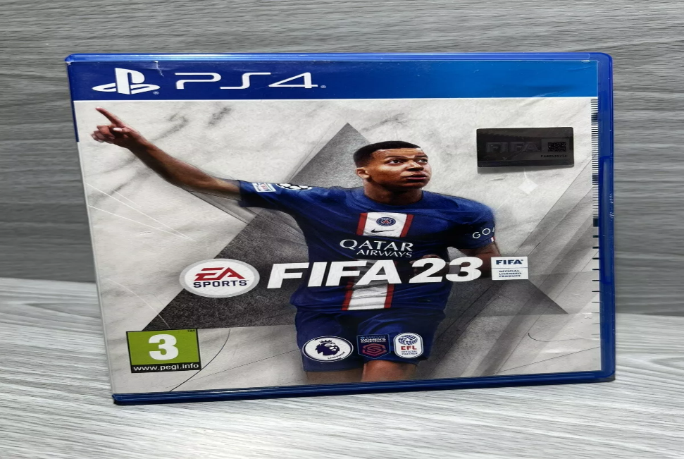

*FIFA 23:*

1️. **HyperMotion2 Technology** *(Next-Gen Only)*

* **More realistic animations, improved ball physics, and AI-driven movements** for lifelike gameplay.

2️. **Women’s Club Football Introduced**

* First FIFA game to feature **women’s club teams**, including the **FA Women’s Super League & Division 1 Féminine**.

3️.**FIFA World Cup Modes**

* Play through the **FIFA World Cup Qatar 2022 (Men’s) and FIFA Women’s World Cup 2023** with official teams and stadiums.

4️. **Revamped Ultimate Team & FUT Moments**

* New **FUT Moments mode**, a redesigned **Chemistry system**, and updated Icons & Heroes for deeper squad-building.

5️.**Cross-Platform Play**

* **Play online against friends on PlayStation, Xbox, and PC** *(same-gen matchmaking: PS5 vs. Xbox Series X/S, PS4 vs. Xbox One)*.